We are making team garments available, as well as personalized yard flags. See below for details.

Example of Swimming T-shirt Example of 12” x 18” Yard Flag
Sweatshirts and Polos also available Several other designs available.
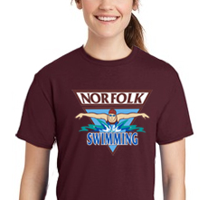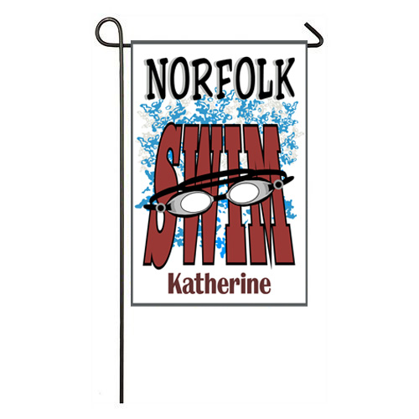
Finished garments and flags will be delivered to swim practice.
Orders placed by Sept 30 will be ready by our first meet. Orders after that date will be subject to availability.
To Order:
Here is the link to the site for Team apparel and Yard Flags.
http://shop.michaelsphotog.com/RedCart/index.php?gnum=240

Below are some tips for using this website:
Once you log in with your e-mail address, click on “Collages, Combos, Garments & Gifts”, then on “Garments” and “Yard Flags” to see the selection of team apparel and yard flags.
In the Shopping Cart:
- When you add garments to the shopping cart, the thumbnail will only show our sample shirt, not necessarily the options you have chosen. To review the details on your garment, click on the balloon next to the thumbnail picture.
- If you are trying to delete something from the shopping cart and it won’t delete, simply wait 30 minutes and it will be able to be deleted.

