USA SWIMMING 2019 ATHLETE REGISTRATION APPLICATION
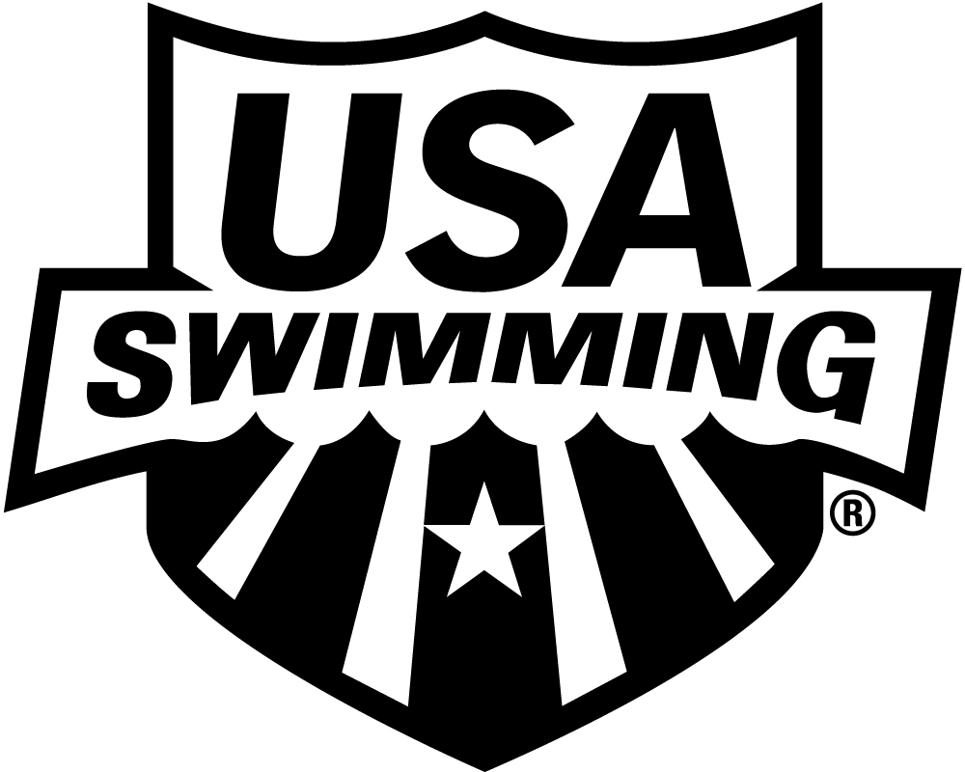
LSC: MIDWESTERN SWIMMING
PLEASE PRINT LEGIBLY COMPLETE ALL INFORMATION:

LAST NAME LEGAL FIRST NAME MIDDLE NAME

PREFERRED NAME DATE OF BIRTH (MO/DAY/YR) SEX (M/F) AGE CLUB CODE NAME OF CLUB YOU REPRESENT
NORFOLK YMCA AQUAJET SWIM TEAM
NYA

(Bill, Beth, Scooter, Liz, Bobby) If not affiliated with a club, enter “Unattached”

FATHER/GUARDIAN #1 LAST NAME FATHER/GUARDIAN #1 FIRST NAME MOTHER/GUARDIAN #2 LAST NAME MOTHER/GUARDIAN #2 FIRST NAME

MAILING ADDRESS

U.S. CITIZEN: YES NO

CITY STATE ZIP CODE
ARE YOU A MEMBER OF ANOTHER FINA
FEDERATION? ☐ YES ☐ NO
IF YES, WHICH FEDERATION:

HAVE YOU REPRESENTED THAT
FEDERATION AT INTERNATIONAL
COMPETITION? ☐ YES ☐ NO

–

AREA CODE TELEPHONE NO. FAMILY/HOUSEHOLD E-MAIL ADDRESS

OPTIONAL
MAKE CHECK PAYABLE TO:

DISABILITY: RACE AND ETHNICITY (You may
YOUR CLUB
A. Legally Blind or Visually Impaired check up to two choices):

B. Deaf or Hard of Hearing Q. Black or African American
MAIL APPLICATION & PAYMENT TO:
C. Physical Disability such as R. Asian

2019 REGISTRATION FEE
Sept. 1, 2018 through Dec. 31, 2019
USA Swimming Fee

LSC Fee

TOTAL DUE $Included in fee
amputation, cerebral palsy, S. White

YOUR CLUB REGISTRAR

dwarfism, spinal injury, T. Hispanic or Latino
mobility impairment U. American Indian & Alaska Native
D. Cognitive Disability such as V. Some Other Race
severe learning disorder, W. Native Hawaiian & Other Pacific
autism Islander

HIGH SCHOOL STUDENTS – Year of high school graduation:
Check if you would like to learn more about the USA Swimming Foundation’s initiatives
Check if you would like to receive the electronic USA Swimming Newsletter (must be 13 years of age or older)
YEAR LAST REGISTERED: . IF YOU REGISTERED WITH A DIFFERENT USA SWIMMING CLUB IN 2018, ENTER THAT
CLUB CODE: LSC CODE: AND THE DATE OF YOUR LAST COMPETITION REPRESENTING THAT CLUB: .

SIGN
HERE x
SIGNATURE OF ATHLETE, PARENT OR GUARDIAN DATE REG. DATE/LSC USE ONLY

