2018-19 REGISTRATION APPLICTION FOR NEW AQUAJET SWIMMERS

|  |  |  |  |  |
| --- | --- | --- | --- | --- |
| FIRST SWIMMER WITH FLEX MEMBERSHIP | | | | |
| One Flex  Membership | Payment in Full | ½ Down Balance in 30 Days | Automatic Withdrawl Payment | |
| Downpayment / 4 equal pymts | |
| $249.00 | $249.00 | $124.50 | $61.00 | $47.00 |

Name________________________________________________ Total for 1st Flex Membership $_____________

|  |  |  |  |  |
| --- | --- | --- | --- | --- |
| EACH ADDITIONAL SWIMMER IN THE SAME FAMILY WITH FLEX MEMBERSHIP | | | | |
| Each Additional Flex Member | Payment in Full | ½ Down Balance in 30 Days | Automatic Withdrawl Payment | |
| Downpayment / 4 equal pymts | |
| $224.00 | $224.00 | $112.00 | $56.00 | $42.00 |

Name________________________________________________ Amount Paid $_____________

Name________________________________________________ Amount Paid $_____________

Name________________________________________________ Amount Paid $_____________

Name________________________________________________ Amount Paid $_____________ Total Additional Flex Membership $_____________

Grand Total Registration Fees Paid FOR FLEX MEMBERSHIP $ _________

|  |  |  |  |  |
| --- | --- | --- | --- | --- |
| STAFF USE ONLY: | | | | |
| AMT PAID DOWN | $__________________ | Balance Due $___________________ | CHECK #_________________________ | TAKEN BY ________ |

CLUB VOLUNTEER POLICY

The Norfolk YMCA Aquajet Swim Team is a non-profit organization operated entirely by volunteers. To ensure the continued success of NYA, each family is required to provide at least one (1) volunteer for each home swim meet that their child is registered for and participation in the annual Ad Campaign Fundraiser. It can take up to 35-40 people to run a successful meet, so everyone needs to be willing to serve as a volunteer in some capacity.

If a volunteer is not provided for the home swim meet in which you have a child participating in the meet, the family will be assessed a $25 fee. The Meet Director will provide a list of jobs (i.e. timer, concessions, clean-up, etc.) required to make each meet successful. Volunteers will have an opportunity to choose which job they wish to do on a first come first served basis

We do understand that sometimes difficult circumstances can arise that might prevent/hinder having a volunteer from your family help at a meet. We want to work with all families if/when these circumstances arise, so communicating with the Meet Director when special needs arise is extremely important.

I have read and understand the Volunteer Policy. I understand that I will be subject to a fine for failure to follow this policy.

X_____________________________________________________ _______________________

Signature of Parent or Guardian Date

 NORFOLK FAMILY YMCA

RELEASE AND WAIVER OF LIABILITY AND INDEMNITY AGREEMENT

In consideration for being permitted to utilize the facilities, services, and programs of the Norfolk Family YMCA (“YMCA”) for any purpose, including but not limited to observation or use of facilities or equipment, or participation in any program affiliated with the YMCA, without respect to location, the undersigned, for himself or herself and any personal representatives, heirs, assignees and successors, hereby acknowledges, agrees and represents that he or she has, or immediately upon entering or participating will inspect and carefully consider such premises and facilities or the affiliated program. It is further warranted that such entry into the YMCA for observation or use of any facilities or equipment or participation in such affiliated program constitutes an acknowledgement that such premises and all facilities and equipment thereon and such affiliated programs have been inspected and carefully considered and that the undersigned finds and accepts same as being safe and reasonably suited for the purpose of such observation, use, or participation.

IN FURTHER CONSIDERATION OF BEING PERMITTED TO ENTER THE YMCA FOR ANY PURPOSE, INCLUDING BUT NOT LIMITED TO OBSERVATION OR USE OF FACILITIES OR EQUIPMENT, OR PARTICIPATION IN ANY PROGRAM AFFILIATED WITH THE YMCA, WITHOUT RESPECT TO LOCATION, THE UNDERSIGNED HEREBY AGREES TO THE FOLLOWING:

1. THE UNDERSIGNED HEREBY RELEASES, WAIVES, DISCHARGES AND COVENANTS NOT TO SUE the YMCA, its directors, officers, employees, and agents (hereinafter referred to as “Releasers”) from all liability to the undersigned, his or her personal representatives, assignees, heirs, and successors for any loss or damage, and any claim or demands therefor on account of injury to the person or property or resulting in death of the undersigned, whether caused by the negligence of the Releasers or otherwise while the undersigned is in, upon, or about the premises or any facilities or equipment therein, or participating in any program affiliated with the YMCA, without respect to location.

2. THE UNDERSIGNED HEREBY AGREES TO INDEMNIFY AND SAVE AND HOLD HARMLESS the Releasers and each of them from any loss, liability, damage, or cost they may incur due to the presence of the undersigned in, upon, or about the YMCA premises or in any way observing or using any facilities or equipment of the YMCA or participating in any program affiliated with the YMCA whether caused by the negligence of the Releasers or otherwise.

3. THE UNDERSIGNED HEREBY ASSUMES FULL RESPONSIBILITY FOR AND RISK OF BODILY INJURY, DEATH, OR PROPERTY DAMAGE due to negligence of Releasers or otherwise while in, about, or upon the premises of the YMCA and/or while using the premises or any facilities or equipment thereon or participating in any program affiliated with the YMCA.

THE UNDERSIGNED further expressly agrees that the foregoing RELEASE AND WAIVER OF LIABILITY AND INDEMNITY AGREEMENT is intended to be as broad and inclusive as is permitted by the law of the State of Nebraska and that if any portion thereof is held invalid, it is agreed that the balance shall, not withstanding, continue in full legal force and effect.

THE UNDERSIGNED HAS READ AND VOLUNTARILY SIGNS THE RELEASE AND WAIVER OF LIABILITY AND INDEMNITY AGREEMENT, and further agrees that no oral representations, statements, or inducement apart from the foregoing written agreement have been made.

I HAVE READ THIS RELEASE

_______/________/__________ ______________________________________________

DATE PARENT’S OR GUARDIAN’S SIGNATURE

Norfolk Family YMCA

301 W. Benjamin Avenue, Norfolk, NE 68701

Phone 402-371-9770 Email swim@norfolkymca.org

### USA SWIMMING 2019 FLEX ATHLETE REGISTRATION APPLICATION

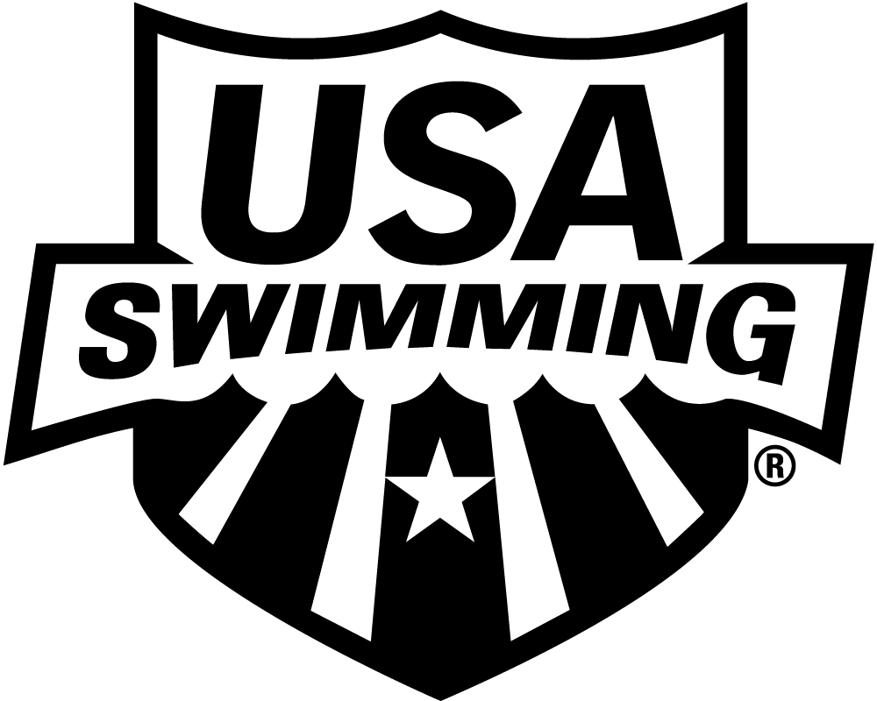

**LSC: MIDWESTERN SWIMMING**

*There is a two sanctioned meet limit on this membership* *THIS MEMBERSHIP IS ONLY FOR MEETS BELOW* ***LSC Championship,*** ***ZONE, SECTIONAL AND NATIONAL LEVELS.***

**PLEASE PRINT LEGIBLY ⚫ COMPLETE ALL INFORMATION:**

# LAST NAME LEGAL FIRST NAME MIDDLE NAME

## PREFERRED NAME DATE OF BIRTH (MO/DAY/YR) SEX (M/F) AGE CLUB CODE NAME OF CLUB YOU REPRESENT

NORFOLK YMCA AQUAJET SWIM TEAM

NYA

**(Bill, Beth, Scooter, Liz, Bobby) If not affiliated with a club, enter “Unattached”**

# FATHER/GUARDIAN #1 LAST NAME FATHER/GUARDIAN #1 FIRST NAME MOTHER/GUARDIAN #2 LAST NAME MOTHER/GUARDIAN #2 FIRST NAME

## MAILING ADDRESS

**U.S. CITIZEN:**  **YES**  **NO**

## CITY STATE ZIP CODE

**ARE YOU A MEMBER OF ANOTHER FINA**

**FEDERATION?  YES  NO**

**IF YES, WHICH FEDERATION:**

**HAVE YOU REPRESENTED THAT**

**FEDERATION AT INTERNATIONAL**

**COMPETITION?  YES  NO**

–

## AREA CODE TELEPHONE NO. FAMILY/HOUSEHOLD E-MAIL ADDRESS

**OPTIONAL**

**MAKE CHECK PAYABLE TO:**

**DISABILITY: RACE AND ETHNICITY** (You may

**YOUR CLUB**

A. Legally Blind or Visually Impaired check up to two choices):

## B. Deaf or Hard of Hearing Q. Black or African American

**MAIL APPLICATION & PAYMENT TO:**

C. Physical Disability *such as*  R. Asian

#### 2019 REGISTRATION FEE

**Sept. 1, 2018 through Dec. 31, 2019**

USA Swimming Fee

##### LSC Fee (max. $10)

# TOTAL DUE $INCLUDED IN FEE

*amputation, cerebral palsy,*  S. White

**YOUR CLUB REGISTRAR**

*dwarfism, spinal injury,*  T. Hispanic or Latino

*mobility impairment*  U. American Indian & Alaska Native

D. Cognitive Disability *such as*  V. Some Other Race

*severe learning disorder,*  W. Native Hawaiian & Other Pacific

*autism*  Islander

**HIGH SCHOOL STUDENTS – Year of high school graduation:**

Check if you would like to learn more about the USA Swimming Foundation’s initiatives

Check if you would like to receive the electronic USA Swimming Newsletter *(must be 13 years of age or older)*

**YEAR LAST REGISTERED:** **. IF YOU REGISTERED WITH A DIFFERENT USA SWIMMING CLUB IN 2018, ENTER THAT**

**CLUB CODE:**  **LSC CODE:** **AND THE DATE OF YOUR LAST COMPETITION REPRESENTING THAT CLUB:** **.**

**SIGN**

**HERE** x

**SIGNATURE OF ATHLETE, PARENT OR GUARDIAN DATE REG. DATE/LSC USE ONLY**

**EMERGENCY CONTACT INFORMATION**

**PARENT CONTACT INFO:**

**MOTHER PHONE #___________________________FATHER PHONE#___________________________**

**EMERGENCY CONTACT OTHER THAN PARENT:**

**RELATION TO SWIMMER____________________ PHONE #___________________________________**

**DOES SWIMMER HAVE ANY HEALTH ISSUES/RISKS YES / NO (CIRCLE ONE)**

**IF YES, EXPLAIN_______________________________________________________________________**

**_____________________________________________________________________________________**

**PLEASE INCLUDE ANY OTHER INFORMATION YOU FEEL COACHES SHOULD KNOW**

**_____________________________________________________________________________________**

**_____________________________________________________________________________________**

**NORFOLK YMCA AQUAJET SWIM TEAM CODE OF CONDUCT /INAPPROPRIATE BEHAVIOR POLICY AGREEMENT**

We are excited to have you join a program that exemplifies a great tradition of excellence. This excellence involves areas that extend far beyond winning and losing. Athletic success is the direct result of the combination of effort, teamwork, commitment, and sportsmanship. We are pleased you have joined this tradition of excellence.

As an athlete, parent/guardian of an athlete, you also have committed yourselves to certain responsibilities and obligations. Your signature on the bottom of this document indicates that you have read, understand and agree to cooperate in enforcing the Norfolk YMCA Aquajet Swim Team Inappropriate Behavior Policy. Compliance with the Code of Conduct/Inappropriate Behavior Policy is mandatory and essential to the success of this athletic program.

**Each athlete and parent must sign and date a copy of the Code of Conduct/Inappropriate Behavior Policy.**

**The following provisions pertain to practices, meets, camps, meetings, clinics, and team events where athletes represent the Norfolk YMCA Aquajet Swim Team.**

**Athletes are expected to:**

* + **Respect and support teammates and their property**
  + **Follow the rules; attend practices, competitions and team events and abide by curfew and instructions**

**Deemed appropriate by the coaches.**

* + **Respect coaches**
  + **Respect all individuals and property of other teams**
  + **Behave in a responsible manner**
  + **Show sportsmanship in and out of the pool**
  + **Know what/when you are swimming**
  + **Swim all entered events**
  + **Talk to a coach before and after each race**

**Part II: Failure to comply with this Code of Conduct/Inappropriate Behavior Policy will result in any or all of the following disciplinary actions.**

1. **An athlete may not be allowed to participate in any or all practices, meets, camp activities, team events, or meetings.**
2. **An athlete may be sent home from practice, meet, clinic, team event or camp.**
3. **An athlete and/or his or her family will be responsible for any damage caused by the athlete.**
4. **An athlete may be suspended from membership with Norfolk Aquajet Swim Team.**

I have read and understand the Code of Conduct/Inappropriate Behavior Policy. I agree to abide by this Policy. I understand that failure to obey this Policy may result in disciplinary actions.

_________________________________________ ________________________________________

Signature of Parent or Guardian Date Signature of Athlete Date

­­­­­­­­­­­­­­­­­­­­­­­­­­­­­­­­­­­­­­­­­­_________________________________________ ________________________________________

Signature of Athlete Date Signature of Athlete Date

_________________________________________ ________________________________________

Signature of Athlete Date Signature of Athlete Date